Train Survivor — Game Design Document
Version 2.0 · 2026-11-06 · Unity 6 LTS (6000.0.85f2), URP, IL2CPP/ARM64, Android portrait
Supersedes v1.0. This revision folds in the Figma gameplay field guide (3 biomes, 64 storyboard states), the content expansion (10 new enemy types, 10 bosses, typed ammo, per-type kill FX), the HUD redesign that puts the level inside the XP bar, and the two-guns-per-wagon rule. Where this document and any older note disagree, this document and the machine-readable files under finalized-for-develop/data/ win.
Version | Date | Headline
1.0 | 2026-11-05 | Original brief: one rail, stop-and-shoot, walker/sprinter/tank, 4 biomes planned
2.0 | 2026-11-06 | Figma field guide imported; 13 enemies, 10 bosses, 7 ammo types, HUD v2, wagon gun slots

What changed in v2
Area | v1.0 | v2.0 (current)
Enemies | 3 types (walker, sprinter, tank) | 13 — those three plus Crawler, Bloater, Spitter, Shrieker, Bulwark, Glider, Drillmaw, Rustmites, The Lantern, Rimeback
Bosses | None specified | 10, each with 3 phases, a named weakness and a telegraph
Ammo | One generic bullet | 7 types: tracer, rocket, fireball, acid glob, tesla arc, pellet spread, bone spike
Kill FX | One gore burst | Impact FX per damage type + death FX per enemy class (10 total)
Level display | Separate TRAIN LV badge | Level number fused into the XP bar's left cap; badge retired
Guns per wagon | Unlimited (one gun per milestone) | Max 2 per wagon, 1 at hitch; second slot via an Extra Gun card
Wagon unlocks | Every 5 levels | LV 1, 5, 10, 15, 20 (5 wagons, 10 guns maximum)
Biomes | 4 planned incl. desert | 3 shipped and storyboarded + desert deferred to v2.1
Stage structure | Abstract 'level' | 20 beats per stage (10 + 10 cards), 1,000 m, phases NAVIGATE/SURVIVE/ENGAGE/EVOLVE (+GROW in biome 3)

1. Core loop
Portrait, one thumb, behind-the-train camera. Holding the screen accelerates and rams; releasing brakes and opens fire. The whole game is the negotiation between those two states.
- Hold → accelerate (0 → 100 % in 0.6 s). Above 60 % speed the cowcatcher deals 35 damage to anything within 3 m and takes none. Guns are off.
- Release → brake burst (0.18 s), wheel sparks, screech. Guns come live at t=0 with no wind-up.
- Brake charge: a meter fills while moving (0 → 100 % over 4 s) and converts into +40 % fire rate for the first 2 s of firing after release.
- Combat → auto-target the nearest enemy, kill, vacuum XP. Adrenaline stacks (+2 % fire rate each, cap 25) decay when idle.
- Blockade → movement clamps to zero until the player releases and shoots it apart.
- Stage clear → 300 ms slow-mo, 3 upgrade cards, next stage.
Design pillar that survived from v1: neither input state may feel like downtime. v2 adds two pressures on that pillar — Bulwarks that ignore frontal fire, and Gliders that disable a gun slot — so stopping is not automatically the safe answer.

1.1 State machine (authoritative)
State | Entered when | Speed | Guns | Other
MOVING | finger held | → target | off | ram on, brake charge += dt
BRAKING | finger released | → 0 in 0.18 s | on at t=0 | sparks, screech, clunk
STOPPED | speed == 0 | 0 | on | targeting active
BLOCKED | held against a blockade within 4 m | 0 | off | player must release
CLEAR | track end reached | → 0 | off | 300 ms slow-mo → reward
DEAD | lead wagon HP ≤ 0 | 0 | off | 250 ms shake → stats → retry
Input is driven by press-held, not TouchPhase.Stationary — Stationary fires on a held but motionless finger and is unreliable across Android devices.

2. Stage structure
Every stage is a 1,000 m run told in 20 beats. The Figma field guide storyboards each beat as one card (300 × 372), and the beats are grouped into five phases that the HUD and the spawn director both read.
Beats | Phase | What happens
01–05 | NAVIGATE | Start line → accel → A/B track split → branch chosen (route A/B rewards differ)
06–09 | SURVIVE | Spawns appear → horde encircles → player releases → train brakes
10–15 | ENGAGE | Target acquisition → volley → hit flashes → kills → leaper interception → boss at 15
16–20 | EVOLVE | XP vacuum → barricade ram → destructible barricade → finish flag → level-up screen
21–24 | GROW | Biome 3 only: convoy growth milestones and the growth reference chart
The A/B split is the only branch in a stage and it happens once, early, so the choice is cheap to test: stage 3–5 in every biome. Route A trades health for speed, route B is the safe line. Later stages may add a second split at beat 16.

2.1 Distance HUD
The top strip is the stage progress bar. Its fill is 228 px of usable track inside a 284 px artwork; 100 % is the finish flag, not the end of the image. The printed distance in the art is baked, so drive the fill from simulated metres, never from the label.

3. Progression

3.1 Level and XP — one bar, not two
v2 retires the separate TRAIN LV badge. The level now lives in a gold chip fused into the left cap of the XP track, with the XP fill running underneath the chip. The chip is always visible, so level and progress to the next level are read in a single glance.
Property | Value
Level chip | 34 × 20 in the 300-space canvas, radius 6, gold border #FFC24D
XP track | 106 × 16, radius 4, #112B45 (unchanged from v1)
Fill | 12 px tall, gradient #5BE0FF → #1E8CD8, runs under the chip
Level number | zero-padded two digits, condensed bold, 16 px in design space
Level up | chip flashes, number rolls to the new value, fill resets to 0
Retired | the TRAIN LV badge that appeared only in biome 3
Rationale: the badge was a third reading of the same number (level), shown far from the thing it changes (XP). One bar means the player learns one place to look.

3.2 The convoy — wagons and gun slots
Each wagon carries at most two guns and arrives with one. The second slot is not free: it costs an Extra Gun upgrade spent on that specific wagon. A full convoy is therefore five wagons and at most ten guns — gun count no longer equals convoy size.
Wagon | Unlocks at | Gun slots | Role
1 (engine) | LV 1 | 1 of 2 | Lead car. Its destruction ends the run.
2 | LV 5 | 1 of 2 | First buffer; first extra gun mount.
3 | LV 10 | 1 of 2 | Mid convoy; unlocks the wide camera step.
4 | LV 15 | 1 of 2 | Heavy mount — rocket and tesla fit here.
5 | LV 20 | 1 of 2 | Final wagon; convoy growth stops here.
Consequence for balance: with 10 gun slots the DPS curve is driven by cards, not by wagon count. A wagon now buys hit points and a mount, not raw damage. Enemy HP scaling is tuned against 10 slots, not 5.

3.3 Upgrades
The offer is 1 of 3 cards after every stage and on level-up. Nine cards currently exist as art in ui/cards/ — the rest of the 24-card pool is still paper-only (see the system design document) and will reuse the same card frame.
Card | Category | Effect
Multishot | Weapon | +2 projectiles per gun, each at reduced damage
Fire Trail | Train | Leaves a burning strip behind the train while moving
Spike Bumper | Train | +35 % ram damage, wider cowcatcher arc
Piercing Rounds | Weapon | Shots pass through one target for 50 % damage
Reinforced Boiler | Train | +20 % max HP on the lead wagon, heals the difference
Rapid Fire Engine | Output | +15 % fire rate across every gun
Incendiary Shells | Elemental | Chance to ignite; burn ticks for 3 s and spreads on death
Extra Gun | Output | Fills the second gun slot of a chosen wagon
Extra Wagon | Train | Hitches a wagon immediately, if under the LV 20 cap
Offer rule (unchanged): always include one card that touches the weakest stat — HP under 35 %, otherwise output — and never three cards of the same category.

4. The horde
Thirteen enemy types. Thematic rule from v1 still holds: everything is a zombie or an infected machine — no aliens, no soldiers, no robots. Each entry states the counter, because an enemy whose counter is not obvious is a bug.
Enemy | HP | Speed | Dmg | Behaviour and counter
Walker | 30 | 2.2 | 6 | Standard shambler, swarms the train · stop early and thin them
Sprinter | 12 | 6.5 | 4 | Fast four-limbed runner · brake immediately
Tank | 255 | 1.2 | 18 | Bloated, huge HP, bullet sponge · sustained fire; the ram does nothing
Crawler | 22 | 4.4 | 4 | Flattens and slides under the cowcatcher; the ram misses it · counter: any bullet, shotgun close range
Bloater | 60 | 2.2 | 18 | Bloats, then detonates for 3 m area damage that also hurts the horde · counter: kill it early (chain reaction), rocket from range
Spitter | 45 | 2.8 | 7 | Lobs acid from the embankment, arcing over barricades · counter: shoot at range, ram it before it settles
Shrieker | 70 | 2.6 | 0 | Screams: +15 % speed aura and a horde call every 8 s · counter: focus it first, rocket into the spawn point
Bulwark | 110 | 2.4 | 12 | Carries a rail-sign plate — immune from the front · counter: bullets that curve in from a side turret, ram from the side
Glider | 35 | 7.0 | 9 | Vaults barricades, lands on a wagon, disables a gun slot for 3 s · counter: tesla chain, shotgun as it lands
Drillmaw | 90 | 3.0 | 15 | Burrows under the track and surfaces ahead of the train · counter: time the brake, watch the dust trail
Rustmites | 6 | 5.2 | 2 | Six bodies, stacking armour shred, needs splash · counter: splash (rocket, fire trail), shotgun
The Lantern | 85 | 2.0 | 6 | Raises fallen zombies as husks until it is killed · counter: rush it, piercing rounds through the husks
Rimeback | 140 | 1.8 | 16 | Armoured brute; its hit chills the throttle for 2 s · counter: fire (melts armour fastest), ram then shoot the cracked plates
HP values are stage-1 baselines before scaling (×1.15 per stage). Full behaviour lists, armour values, spawn lanes and pack sizes live in finalized-for-develop/data/enemies.json.
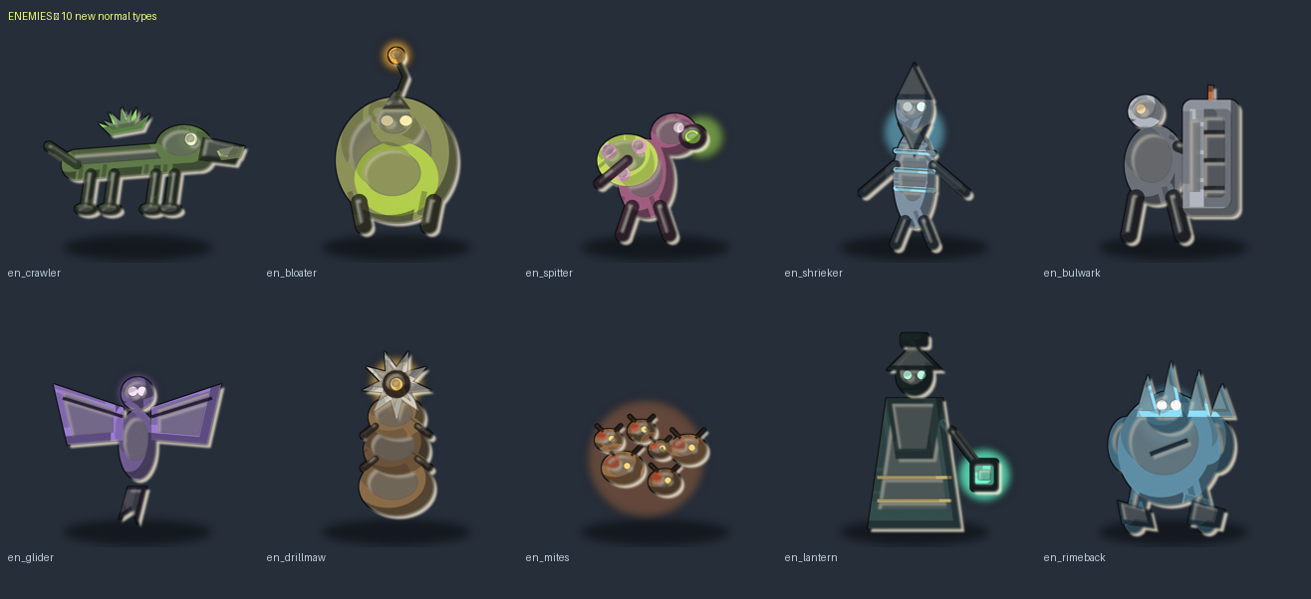

4.1 New in v2 — why each one exists
- Crawler — attacks the ram, not the guns: it flattens and slides under the cowcatcher, so the reflex that works on everything else fails.
- Bloater — turns the horde into a hazard: its blast damages other enemies, so letting it reach the train can be a tactic.
- Spitter — punishes parking: fires from the embankment, so the player who stops and shoots everything else must move.
- Shrieker — a priority target that is harmless alone; killing it early is the reward for reading the field.
- Bulwark — makes frontal DPS insufficient, which is what finally makes turret placement matter.
- Glider — attacks the convoy instead of the lead car, and disables a gun slot, converting a wagon into a liability for 3 s.
- Drillmaw — makes the ground a threat and gives the brake a second use: waiting for it to surface.
- Rustmites — forces splash in the build, and stacks armour shred so tanking them is not viable.
- The Lantern — gives the horde a healer, creating a kill-order problem instead of a DPS problem.
- Rimeback — punishes the ram-first playstyle by chilling the throttle, and rewards fire.

5. Bosses
One boss per biome per act, ten in total, met at beat 15 of a stage. Every boss has three phases with HP thresholds, a named weakness, and at least one attack that the player must answer with the brake. No boss may be defeated by holding the screen.
Boss | Biome | HP | Phases | Weakness
The Inferno | Burning Metropolis | 2400 | P1 Molten Walk → P2 Vent (55 %) → P3 Overheat (25 %) | chest vent only in phase 2+
Railmaw | Burning Metropolis | 1900 | P1 Coil → P2 Squeeze (60 %) → P3 Collapse (30 %) | teeth ring: shoot the mouth during the coil
Slagheart | Burning Metropolis | 2600 | P1 Bellows → P2 Stoke (50 %) → P3 Meltdown (20 %) | the grate
The Conductor | Burning Metropolis | 2100 | P1 Timetable → P2 Delay (60 %) → P3 Last Call (25 %) | lamp staff arm — break it to stop the blind
Glacier Maw | Frozen Canyon | 3000 | P1 Bite → P2 Shell (60 %) → P3 Thaw (25 %) | between plates at the jaw hinge
Rime Engine | Frozen Canyon | 3200 | P1 Head-on → P2 Boiler Burst (60 %) → P3 Derail (25 %) | the headlight — shoot it to blind its aim
Mireheart | Toxic Swamp | 2800 | P1 Rooted → P2 Uproot (70 %) → P3 Bloom (30 %) | the stalk under the cap
Hollow Queen | Toxic Swamp | 2500 | P1 Brood → P2 Rupture (60 %) → P3 Last Eggs (30 %) | eggs — they are the real health bar
Iron Choir | Frozen Canyon | 3600 | P1 Three Voices → P2 Discord (60 %) → P3 Silence (20 %) | the chain links between torsos (breaks the sync)
The Nightmail | Toxic Swamp | 4200 | P1 Phantom → P2 Twin (65 %) → P3 Terminus (30 %) | the headlight lanterns — break both to stop the phasing
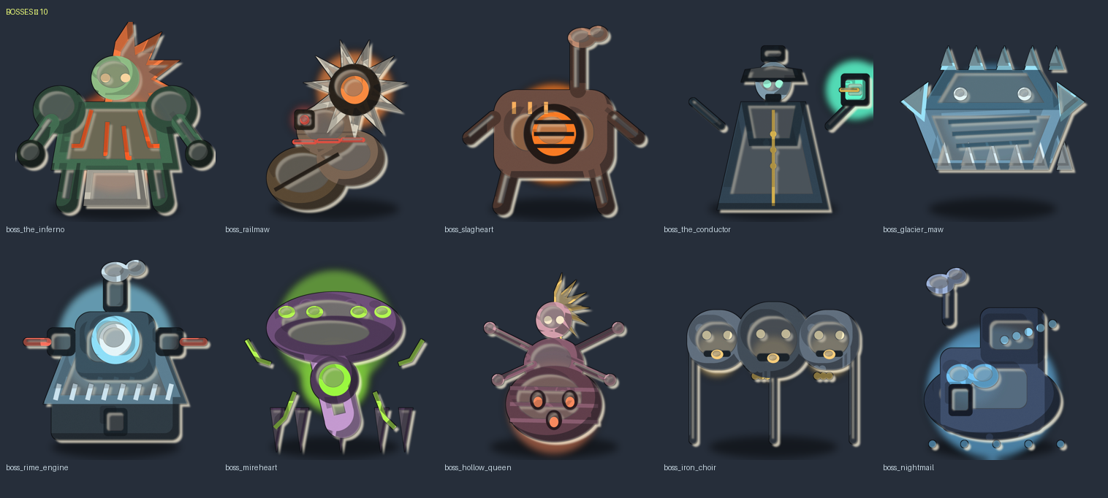
Full attack lists, arena notes, entry beats and rewards are in finalized-for-develop/data/bosses.json, and readable in finalized-for-develop/BESTIARY.md.
Two bosses carry the theme hardest. Rime Engine is a mirror fight — a corrupted locomotive coming at you on your own rails, with its own turrets. The Nightmail phases out of the world, splits into a true and an illusory copy, and forces an A/B choice mid-fight; the illusion never touches the rails, which is the tell.

6. Guns, ammo and damage types
v1 shared one bullet sprite across every weapon. v2 types the ammo per gun, so the weapon silhouette, the projectile and the hit FX all agree.
Gun | Ammo | Type | Behaviour
CANNON | Tracer round | kinetic | Cannon + gatling. Fast, no splash, pierces 1.
GATLING | Tracer round | kinetic | Cannon + gatling. Fast, no splash, pierces 1.
ROCKET | Rocket | blast | Rocket launcher. Arcs slightly, big splash, slow.
TESLA | Tesla arc | electric | Tesla coil. Chains to a second target, stuns briefly.
FIRE | Fireball | fire | Flamer / fire card. Ignites ground, damage over time.
SHOTGUN | Pellet spread | kinetic | Shotgun. 5 pellets, wide cone, close range.
ACID | Acid glob | acid | Acid turret + spitters. Shreds armour, leaves a pool.
— (enemy) | Bone spike | kinetic | Enemy ranged attack: spitter, conductor, queen

6.1 Damage type behaviour
Type | On hit | Kill
kinetic | hit flash, small knockback | goo / bone burst, metal shatter for armoured
blast | 3 m radius, falloff 50 % at the edge | ring burst + plate shards
fire | burn 8 dmg/s for 3 s, spreads on death | fire burst with embers
acid | −10 % armour for 5 s, leaves a pool | acid splash + puddle
electric | chains to one extra target within 4 m | arc burst
Ammo sprites are in finalized-for-develop/projectiles/, FX in finalized-for-develop/fx/, and the mapping is data/fx.json. Impact FX are looked up by damage type; death FX by enemy class — they are deliberately two lookups, so a fire kill on a metal enemy shows both.

7. HUD and UI
The HUD is authored on a 300 × 300 gameplay canvas and scaled by screenWidth / 300. It is drawn from a small set of rounded bars and one illustrated distance strip; the level-up screen is a separate 576 × 1024 canvas.
Element | Design size | Notes
Status bar | 284 × 27, r5 | #0E1822 at 94 %, 8 px inset, bottom-anchored
HP / XP track | 106 × 16, r4 | HP #123617, XP #112B45
HP / XP fill | 12 px tall, r2 | inset 2 px; 102 px of track = 100 %
Bar row | HP 10→144, XP 155→289 | 11 px gutter between bars
Distance HUD | 284 × 50 at y 5 | fill 11 px, x 38 → 266; 228 px = full stage
Touch chip | 32 × 41, r4 | 253,177 — HOLD / RELEASE / AUTO / READY
Boss bar | 190 × 33 at 55,54 | track 178 × 6, name 11 px above
Upgrade card | 88 × 200 (art 80 × 120) | 3-up row 284 wide, 6 px gutters
Level chip (v2) | 34 × 20, r6 | fused into the XP track's left cap

Percentages in the design tables are measured from the drawn fills against their usable track, not the node width — the fills are inset 2 px, so a full HP bar is a 102 px fill and a complete stage is 228 px of distance fill.
Wagon gun slots have their own plaque: two 80 × 76 slots, slot 1 filled and slot 2 dashed and marked LOCKED until an Extra Gun is spent. It sits above the convoy when a wagon is focused, never permanently on screen.

8. Biomes and art direction
Three biomes are storyboarded and shipped. Each has its own palette, its own convoy mark and its own loadout accent; enemies are not recoloured between biomes — the palette and the environment do that work, tinting the sprites breaks the painted lighting.
Biome | Premise | Convoy | Palette (first five) | Beats
Burning Metropolis | Ember-lit avenues. A broken city. One way out. | IRONCLAD Mk I | #2E323C · #292934 · #353137 · #2D1F27 · #454944 | 20
Frozen Canyon | Subzero rails. Icebound predators. Keep the engine alive. | IRONCLAD Mk II | #2C6D8C · #1D5F8F · #0F3A73 · #08152C · #1D538C | 20
Toxic Swamp | Poison water. Hungry shadows. Burn a path through the mire. | IRONCLAD Mk III | #1D382C · #25362A · #192422 · #1A202C · #273536 | 24
A fourth biome — abandoned desert wasteland — was in the v1 plan and is deferred. When it arrives it must bring its own enemies, not palette swaps, or it will read as filler.
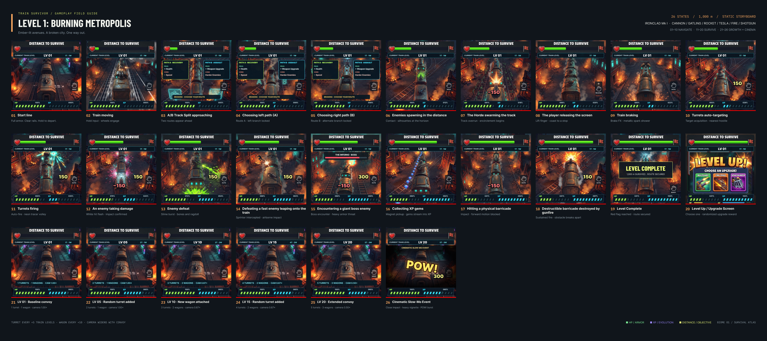

8.1 Visual rules
- Thick dark outline on every sprite; light from the upper left; a single accent emissive per enemy (eyes, core, lantern).
- Hit flash is white and total for 40 ms — no partial tinting, it reads as damage only if it is unambiguous.
- Gore is stylised chunks, never realism; four gore palettes, one per biome plus a generic.
- Silhouette first: an enemy must be identifiable at 40 px tall, which is its size on a 6-inch screen at 12 m.

9. Build status and pipeline
The game exists and runs. The simulation is UnityEngine-free (TrainSurvivor.Core), so balance rules are EditMode tests that finish in about a second.
System | State
Unity | 6 LTS 6000.0.85f2, URP, IL2CPP/ARM64, Android
Core sim | movement, brake charge, ram, targeting, blockades, XP, cards, stage clear, seeded determinism
Tests | 20 EditMode tests, green
Art | two atlases (world + UI) packed from the source sheets, loaded through ArtSprites
Design export | design/figma/ — 3 boards, 64 state renders, spec JSON, tokens
Asset kit | finalized-for-develop/ — 210 catalogued assets, data JSON, catalog, BESTIARY
Open for M1 | ambush telegraphs beyond the blockade warning, brake-charge UI, forks
Art status, stated plainly: the ten new enemies and ten bosses currently ship as generated placeholder sprites so the roster can be wired and tested. The design cards next to them are the authoritative brief, and every entry in data/*.json carries a prompt string for the art pipeline. Painted art drops over the placeholder filename with no code change.

9.1 Asset locations
Need | Path
HUD pieces, cards, control chip | finalized-for-develop/ui/
Enemies and bosses (sprites + design cards) | finalized-for-develop/enemies/, bosses/
Ammo and kill FX | finalized-for-develop/projectiles/, fx/
Rosters, rules, HUD spec | finalized-for-develop/data/
Gameplay frames per beat | finalized-for-develop/screens/<biome>/
Figma source boards and renders | design/figma/

10. AI implementation directives
Short form, for handing to a code generator. The loop is a state machine; everything else is data.
- Moving: press held → speed accelerates along the spline; auto-targeting OFF; ram ON above 60 %; brakeCharge += dt.
- Stopped: no press → speed lerps to 0 in 0.18 s; guns ON immediately; target nearest enemy by spline distance; fire the gun's ammo type.
- Blocked: blockade within 4 m while held → speed 0, guns OFF until release.
- Guns live in wagon slots: slot[0] always present on a hitched wagon, slot[1] requires an Extra Gun; a wagon never holds more than 2.
- Wagon milestones: LV 1, 5, 10, 15, 20 — hitch a wagon at each, never more than 5.
- Level: award XP per kill, roll the level chip in the XP bar, never render a separate TRAVEL LV badge.
- Boss: at beat 15, load the biome boss, apply phase thresholds from data/bosses.json, and switch attack sets at 60 % and 25 % HP (per-boss values in the data).
- Kill: look up death FX by enemy class and impact FX by damage type — both lookups, every time.
- Fail: lead wagon HP ≤ 0 → DEAD → stats → retry in under a second; meta upgrades persist, run upgrades do not.
- Determinism: seeded RNG for card offers, drops and spawns; a run is {seed, inputTimeline} and must replay to an identical state hash.

11. Open decisions
- Desert biome: keep deferred, or build as a v2.1 act with its own enemy set?
- Second A/B split later in a stage — does it add choice or just friction at speed?
- Does the Extra Gun card target a wagon chosen by the player, or auto-fill the lowest-index free slot?
- Boss cadence: one per stage at beat 15, or boss stages interleaved between normal stages?
- Gun cap: 10 slots is a lot of simultaneous tracers — confirm the 300-bullet budget holds on low-end.

